**UNIVERSITY OF ENGINEERING AND TECHNOLOGY, LAHORE**

**(NAROWAL CAMPUS)**



**NAME :**

**ABDULAHAD HUSSAIN**

**ROLL NO. :**

**549**

**SECTION:**

**A**

**SUBJECT:**

**PROGRAMING FUNDAMENTAL**

**Objective:**

C++ is most popularly used for building large software infrastructure and applications that run on limited resources, for example gaming programing, data structure. The main purpose of C++ programing was to add object oriented to the C programing.

**Data Type:**

* Integer (int)
* Floating (float)
* Character (char)
* String (str or text)
* Boolean (bool)
* Array

**Variable:**

Variables in C++ is **a name given to a memory location**. It is the basic unit of storage in a program. The value stored in a variable can be changed during program execution. A variable is only a name given to a memory location. All the operations done on the variable effects that memory location

**Operators:**

**C++ arithmetic operators**:

* Addition (+)
* Subtraction (-)
* Multiplication (*)
* Division (/)
* Modulus operator (%)

**Precedence of operator:**

|  |  |  |  |  |  |  |  |  |  |  |  |  |  |
| --- | --- | --- | --- | --- | --- | --- | --- | --- | --- | --- | --- | --- | --- |
| C operation | | | | Operation | | | | | Order of operation | | | | |
|  | () |  | |  | Paranthesis | |  | |  | The expression in parenthesis is | | |  |
|  |  | |
| evaluated first. |  | |
| In case of nested paranthesis the part of expression in the inner most parenthesis is | | |
| evaluated first. |  | |
| Unary + and - | | | | Addition & subtraction | | | | | From left to right | | | | |
|  | *,%,/ | |  |  | Multiplication, Division, | | |  |  | From left to right | |  | |
|  | | Modulus |  | |  | |
| Binary + or - | | | | Addition  Subtraction | | | | | From left to right | | | | |

**LAB #02:**

**Program No. 1:**

**Statement:**

Get two integer from user as input and calculate and print their sum, difference, quotient and remainder.

**Alogarithm:**   **START**

Step 1: Declare two variable a and b.

Step 2: Assign their data type that is integer.

Step 3: Take value from user by using **“cin”** command. Step 4: Now apply arithmetic operation on a and b that is (+,-,*,/,%).

Step 5: Print their result by using **“cout”** command**.**

**END**

**Programe:** 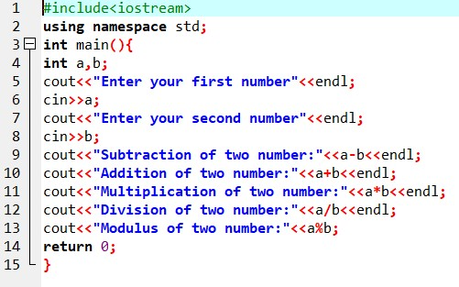

**Output:**

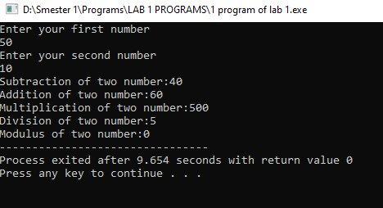

**Program No. 2:**

**Statement:**

Ali’s basic salary is entered through the keyboard. If his house rent allowance is 40 percent of basic salary and transport allowance is 20 percent of basic salary. Then write a program that determines his gross salary.

**Alogarithm:**

**START**

Step 1: Declare four variable basic, house, transport and gross.

Step 2: Take basic salary from user and store in basic.

Step 3: Calculate 40% house rent using this formula (house = basic * 0.4).

Step 4: Calculate 20% transport allowance by using this formula (transport = basic * 0.2).

Step 5: Calculate gross salary by using this formula (gross = basic + house + transport).

Step 6: Print value on screen.

**END**

**Program:**

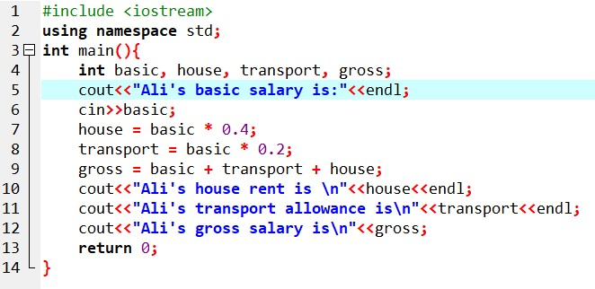

**Output:**

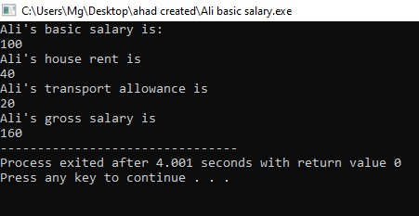

**Program No 3:**

**Statement:**

Get an integer as input from

keyboard. Determine it is whether even or oddin nature.

**Alogarithm:**

**START**

Step 1: Declare three variables a, b and c.

Step 2: Take two values from user and store them in a and b and third variable c is empty.

Step 3: Using operation c=a, a=b and b=c.

Step 4: Print the value of a and b.

**END**

**Program:**

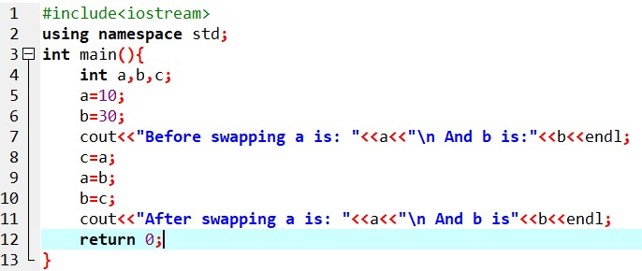

**Output:**

